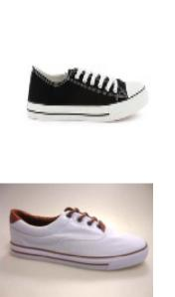

10 men | canvas
8 men | canvas
5 men | canvas
8 men | sport
9 men | canvas
9 men | canvas
8 men | canvas
4 men | canvas
4 men | canvas
30 men | canvas
8 men | canvas
27 men | canvas
3 men | canvas
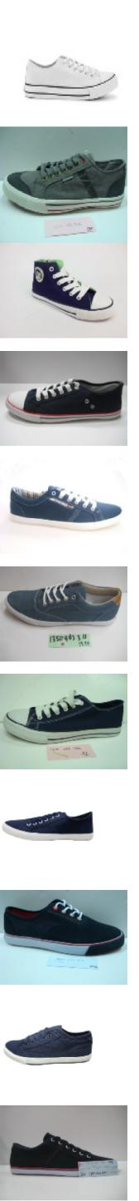
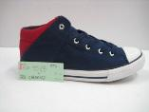
4 men | canvas
8 men | canvas
23 men | canvas
1 men | canvas
14 men | canvas
5 men | canvas
12 men | canvas
2 men | canvas
5 men | canvas
33 men | canvas
1 men | canvas
18 men | canvas
68 men | canvas
1 men | canvas
45 men | canvas
47 men | canvas
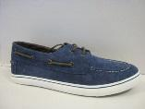
13 men | canvas
23 men | canvas
5 men | canvas
5 men | canvas
5 men | canvas
334 men | canvas
4 men | canvas
3 men | canvas
13 men | canvas
12 men | canvas
4 men | canvas
7 men | canvas
5 men | canvas
2 men | canvas
5 men | canvas
60 men | canvas
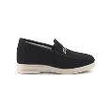
5 men | canvas
37 men | canvas
4 men | canvas
7 men | canvas
26 men | canvas
15 men | canvas
9 men | canvas
5 men | canvas
49 men | canvas
4 men | canvas
16 men | canvas
1 men | canvas
3 men | canvas
1 men | canvas
3 men | canvas
15 men | canvas
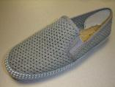
4 men | canvas
4 men | canvas
14 men | canvas
3 men | canvas
6 men | canvas
20 men | canvas
9 men | canvas
6 men | canvas
1 men | canvas
23 men | canvas
2 men | canvas
21 men | canvas
14 men | canvas
1 men | canvas
1 men | canvas
1 men | canvas
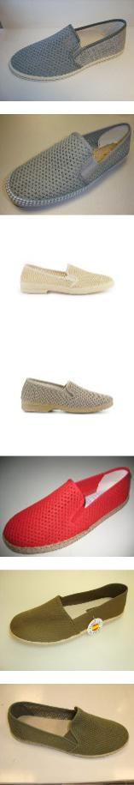
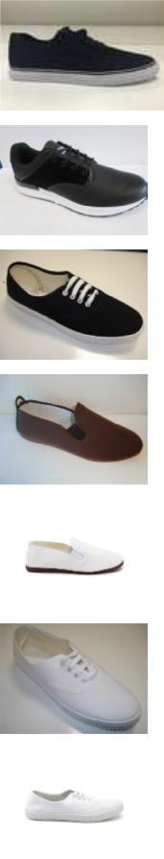
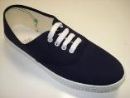
16 men | canvas
5 men | canvas
19 men | canvas
2 men | canvas
39 men | canvas
8 men | canvas
14 men | canvas
1 men | canvas
7 men | canvas
3 men | canvas
43 men | canvas
1 men | canvas
1 men | canvas
1 men | canvas
2 men | canvas
1 men | canvas
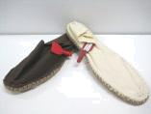
7 men
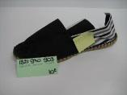

2 men
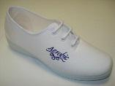

1 women
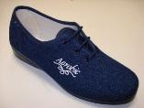

5 women
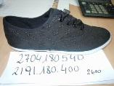

1 women
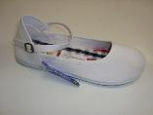

1 women

3 women
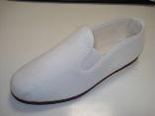

8 women
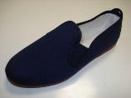

11 women

7 women
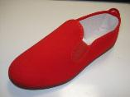

15 women
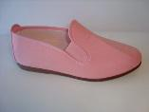

5 women
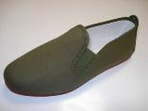

4 women
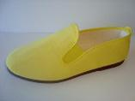

9 women
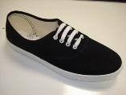

1 women

5 women

canvas

canvas

canvas

canvas

canvas

canvas

canvas

canvas

canvas

canvas

canvas

canvas

canvas

canvas

canvas

canvas
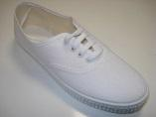
5 women | canvas
5 women | canvas
2 women | canvas
14 women | canvas
14 women | canvas
21 women | canvas
1 women | canvas
12 women | canvas
1 women | canvas
1 women | canvas
20 women | canvas
4 women | canvas
11 women | canvas
16 women | canvas
100 women | canvas
4 women | canvas
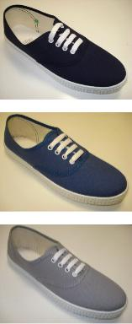
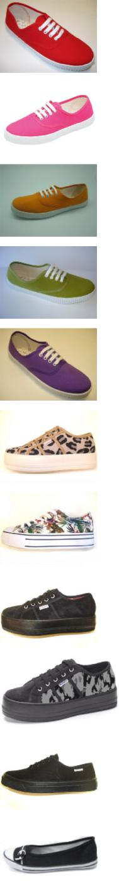
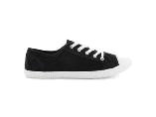
1 women | canvas
6 women | canvas
16 women | canvas
6 women | canvas
8 women | canvas
3 women | canvas
3 women | canvas
1 women | canvas
51 women | canvas
1 women | canvas
2 women | canvas
2 women | canvas
1 women | canvas
1 women | canvas
5 women | canvas
14 women | canvas
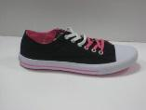
2 women | canvas
41 women | canvas
4 women | canvas
17 women | canvas
1 women | canvas
2 women | canvas
9 women | canvas
1 women | canvas
1 women | canvas
17 women | canvas
35 women | canvas
6 women | canvas
1 women | canvas
11 women | canvas
4 women | canvas
3 women | canvas
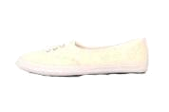
13 women | canvas
1 women | canvas
2 women | canvas
8 women | canvas
8 women | canvas
7 women | canvas
8 women | canvas
6 women | canvas
25 women | canvas
3 women | canvas
18 women | canvas
25 women | canvas
22 women | canvas
9 women | canvas
1 women | canvas
3 women | canvas
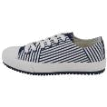
3 women | canvas
2 women | canvas
6 women | canvas
2 women | canvas
3 women | canvas
18 women | canvas
3 women | canvas
1 women | canvas
1 women | canvas
2 women | canvas
6 women | canvas
6 women | canvas
32 women | canvas
5 women | canvas
1 women | canvas
3 women | canvas
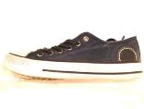
11 women | canvas
2 women | canvas
75 women | canvas
2 women | canvas
12 women | canvas
1 women | canvas
7 women | canvas
13 women | canvas
1 women | canvas
44 women | canvas
22 women | canvas
9 women | canvas
4 women | canvas
7 women | canvas
4 women | canvas
1 women | canvas
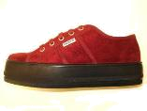
1 women | canvas
2 women | canvas
4 women | canvas
4 women | canvas
5 women | canvas
1 women | canvas
2 women | canvas
2 women | canvas
10 women | canvas
7 women | canvas
25 women | canvas
2 women | canvas
1 women | canvas
4 women | canvas
29 women | canvas
3 women | canvas
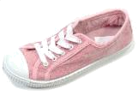
4 women | canvas
6 women | canvas
1 women | canvas
2 women | canvas
5 women | canvas
1 women | canvas
17 women | canvas
21 women | canvas
2 women | canvas
1 women | canvas
1 women | canvas
22 women | canvas
8 women | canvas
10 women | canvas
3 women | canvas
17 women | canvas
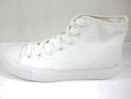
49 women | canvas
14 women | canvas
9 women | canvas
15 women | canvas
27 women | canvas
26 women | canvas
6 women | canvas
4 women | canvas
14 women | canvas
11 women | canvas
6 women | canvas
82 women | canvas
2 women | canvas
226 women | canvas
106 women | canvas
25 women | canvas
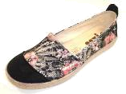
15 women | canvas
18 women | canvas
9 women | canvas
1 women | canvas
21 women | canvas
36 women | canvas
1 women | canvas
2 women | canvas
1 women | canvas
7 women | canvas
1 women | canvas
3 women | canvas
5 women | canvas
14 women | canvas
74 women | canvas
10 women | canvas
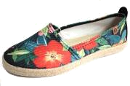
15 women | canvas
5 women | canvas
2 women | canvas
9 women | canvas
11 women | canvas
3 women | canvas
26 women | canvas
39 women | canvas
3 women | canvas
10 women | canvas
26 women | canvas
2 women | canvas
165 women | canvas
50 women | canvas
17 women | canvas
49 women | canvas
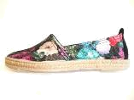
3 women | canvas
3 women | canvas
1 women | canvas
2 women | canvas
1 women | canvas
2 women | canvas
3 women | canvas
1 women | canvas
33 women | canvas
15 women | canvas
11 women | canvas
11 women | canvas
1 women | canvas
8 women | canvas
10 women | canvas
14 women | canvas
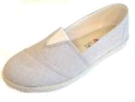
3 women | canvas
2 women | canvas
13 women | canvas
9 women | canvas
6 women | canvas
3 women | canvas
4 women | canvas
2 women | canvas
169 women | canvas
16 women | canvas
83 women | canvas
13 women | canvas
2 women | canvas
4 women | canvas
13 women | canvas
196 women | canvas
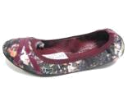
22 women | canvas
8 women | canvas
2 women | canvas
18 women | canvas
1 women | canvas
10 women | canvas
150 women | canvas
47 women | canvas
31 women | canvas
2 women | canvas
7 women | canvas
5 women | canvas
42 women | canvas
13 women | canvas
27 women | canvas
113 women | canvas
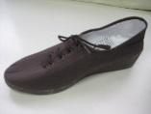
14 women | canvas
62 women | canvas
60 women | canvas
27 women | canvas
1 women | canvas
38 women | canvas
20 women | canvas
92 women | canvas
14 women | canvas
8 women | canvas
6 women | canvas
3 women | canvas
11 women | canvas
8 women | canvas
12 women | canvas
8 women | canvas
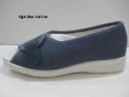
52 women | canvas
10 women | canvas
18 women | canvas
12 women | canvas
5 women | canvas
4 women | canvas
2 women | canvas
14 women | canvas
49 women | canvas
29 women | canvas
79 women | canvas
8 women | canvas
2 women | canvas
15 women | canvas
20 women | canvas
4 women | canvas
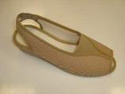
14 women | canvas
16 women | canvas
1 women | canvas
12 women | canvas
13 women | canvas
1 women | canvas
3 women | canvas
5 women | canvas
52 women | canvas
7 women | canvas
31 women | canvas
1 women | canvas
3 women | canvas
1 women | canvas
4 women | canvas
2 women | canvas
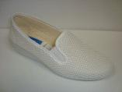
4 women | canvas
5 women | canvas
3 women | canvas
2 women | canvas
20 women | canvas
16 women | canvas
11 women | canvas
18 women | canvas
3 women | canvas
3 women | canvas
1 women | canvas
1 women | canvas
1 women | canvas
5 women | canvas
11 women | canvas
26 women | canvas
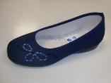
3 women | canvas
4 women | canvas
6 women | canvas
107 women | canvas
6 women | canvas
45 women | canvas
18 women | canvas
7 women | canvas
1 women | canvas
4 women | canvas
1 women | canvas
6 women | canvas
58 women | canvas
37 women | canvas
29 women | canvas
7 women | canvas
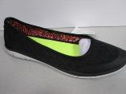
12 women | canvas
10 women | canvas
9 women | canvas
13 women | canvas
36 women | canvas
2 women | canvas
11 women | canvas
5 women | canvas
14 women | canvas
1 women | canvas
1 women | canvas
35 women | canvas
31 women | canvas
59 women | canvas
7 women | canvas
7 women | canvas
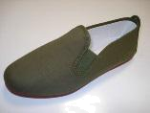
3 women | canvas
2 women | canvas
101 women | canvas
9 women | canvas
4 women | canvas
3 women | canvas
3 women | canvas
4 women | canvas
5 women | canvas
8 women | canvas
15 women | canvas
9 women | canvas
21 women | canvas
2 women | canvas
38 women | canvas
2 women | canvas
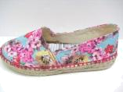
34 women |  | canvas
13 women |  | canvas
2 women |  | canvas
4 women |  | canvas
5 women |  | canvas
4 women |  | canvas
1 women |  | canvas
7 women |  | canvas
5 women |  | canvas
12 | children | canvas
17 | children | canvas
3 | children | canvas
4 | children | canvas
6 | children | canvas
2 | children | canvas
3 | children | canvas
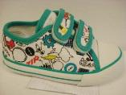
2 | children | canvas
10 | children | canvas
15 | children | canvas
1 | children | canvas
2 | children | canvas
1 | children | canvas
5 | children | canvas
3 | children | canvas
5 | children | canvas
14 | children | canvas
15 | children | canvas
6 | children | canvas
3 | children | canvas
14 | children | canvas
2 | children | canvas
2 | children | canvas
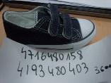
2 | children | canvas
8 | children | canvas
6 | children | canvas
6 | children | canvas
3 | children | canvas
13 | children | canvas
3 | children | canvas
3 | children | canvas
2 | children | canvas
2 | children | canvas
17 | children | canvas
7 | children | canvas
1 | children | canvas
2 | children | canvas
3 | children | canvas
4 | children | canvas
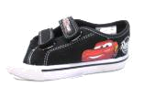
3 | children | canvas
23 | children | canvas
7 | children | canvas
9 | children | canvas
1 | children | canvas
5 | children | canvas
4 | children | canvas
2 | children | canvas
3 | children | canvas
2 | children | canvas
4 | children | canvas
6 | children | canvas
2 | children | canvas
8 | children | canvas
4 | children | canvas
41 | children | canvas
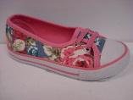
2 | children | canvas
51 | children | canvas
105 | children | canvas
158 | children | canvas
13 | children | canvas
11 | children | canvas
25 | children | canvas
35 | children | canvas
8 | children | canvas
9 | children | canvas
1 | children | canvas
1 | children | canvas
2 | children | canvas
11 | children | canvas
17 | children | canvas
22 | children | canvas
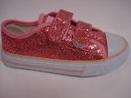
9 | children | canvas
19 | children | canvas
28 | children | canvas
53 | children | canvas
1 | children | canvas
2 | children | canvas
34 | children | canvas
43 | children | canvas
66 | children | canvas
18 | children | canvas
3 | children | canvas
18 | children | canvas
1 | children | canvas
10 | children | canvas
9 | children | canvas
1 | children | canvas
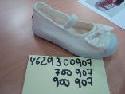
8 | children | canvas
8 | children | canvas
5 | children | canvas
7 | children | canvas
6 | children | canvas
14 | children | canvas
9 | children | canvas
2 | children | canvas
2 | children | canvas
2 | children | canvas
8 | children | canvas
2 | children | canvas
2 | children | canvas
2 | children | canvas
1 | children | canvas
14 | children | canvas
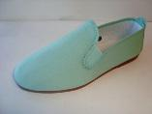
1 | children | canvas
6 | children | canvas
19 | children | canvas
1 | children | canvas
56 | children | canvas
1 | children | canvas
1 | children | canvas
1 | children | canvas
6 | children | canvas
46 | children | canvas
2 | children | canvas
15 | children | canvas
6 | children | canvas
5 | children | canvas
1 | children | canvas
1 | children | canvas
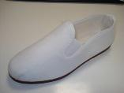
6 | children | canvas
8 | children | canvas
10 | children | canvas
6 | children | canvas
3 | children | canvas
8 | children | canvas
10 | children | canvas
6 | children | canvas
3 | children | canvas
5 | children | canvas
1 | children | canvas
7 | children | canvas
17 | children | canvas
2 | children | canvas
8 | children | canvas
5 | children | canvas
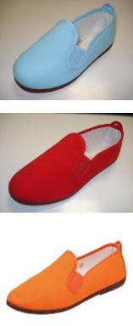
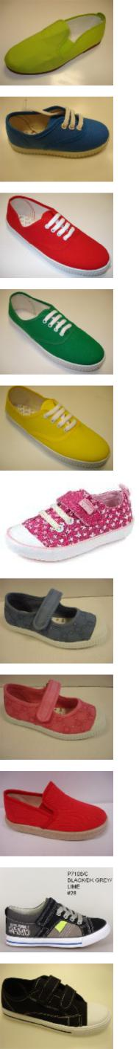
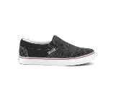
1 | children | canvas
1 | children | canvas
3 | children | canvas
8 | children | canvas
13 | children | canvas
1 | children | canvas
7 | children | canvas
3 | children | canvas
1 | children | canvas
4 | children | canvas
1 | children | canvas
2 | children | canvas
3 | children | canvas
12 | children | canvas
1 | children | canvas
2 | children | canvas
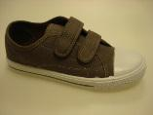
1 | children | canvas
1 | children | canvas
27 | children | canvas
4 | children | canvas
13 | children | canvas
1 | children | canvas
21 | children | canvas
5 | children | canvas
2 | children | canvas
62 | children | canvas
62 | children | canvas
3 | children | canvas
6 | children | canvas
3 | children | canvas
10 | children | canvas
55 | children | canvas
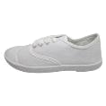
9 | children | canvas
6 | children | canvas
30 | children | canvas
17 | children | canvas
13 | children | canvas
8 | children | canvas
42 | children | canvas
35 | children | canvas
1 | children | canvas
5 | children | canvas
1 | children | canvas
3 | children | canvas
6 | children | canvas
4 | children | canvas
17 | children | canvas
9 | children | canvas
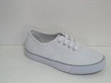
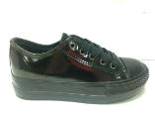
1 | children | canvas
3 | children | canvas
16 | children | canvas
9 | children | canvas
14 | children | canvas
14 | children | canvas
19 | children | canvas
41 | children | canvas
4 | children | canvas
13 | children | canvas
12 | children | canvas
15 | children | canvas
1 | children | canvas
10 | children | canvas
24 | children | canvas
1 | children | canvas
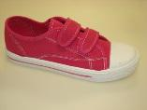
18 | children | canvas
15 | children | canvas
1 | children | canvas
8 | children | canvas
5 | children | canvas
6 | children | canvas
29 | children | canvas
17 | children | canvas
28 | children | canvas
16 | children | canvas
23 | children | canvas
1 | children | canvas
58 | children | canvas
6 | children | canvas
87 | children | canvas
4 | children | canvas
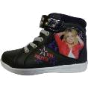
62 | children | canvas
8 | children | canvas
18 | children | canvas
6 | children | canvas
1 | children | canvas
13 | children | canvas
8 | children | canvas
2 | children | canvas
5 | children | canvas
16 | children | canvas
9 | children | canvas
8 | children | canvas
38 | children | canvas
2 | children | canvas
1 | children | canvas
2 | children | canvas
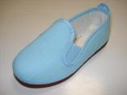
1 | children | canvas
14 | children | canvas
23 | children | canvas
22 | children | canvas
7 | children | canvas
13 | children | canvas
17 | children | canvas
10 | children | canvas
7 | children | canvas
2 | children | canvas
1 | children | canvas
6 | children | canvas
2 | children | canvas
3 | children | canvas
7 | children | canvas
13 | children | canvas
2 | children | canvas
4 | children | canvas
6 | children | canvas
2 | children | canvas
4 | children | canvas
8 | children | canvas
8 | children | canvas
44 | children | canvas
3 | children | canvas
3 | children | canvas
15 | children | canvas
9 | children | canvas
17 | children | canvas
1 | children | canvas
2 | children | canvas
2 | children | canvas
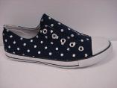
4 | children | canvas
3 | children | canvas
1 | children | canvas
3 | children | canvas
1 | children | canvas
15 | children | canvas
3 | children | canvas
7 | children | canvas
24 | children | canvas
22 | children | canvas
10 | children | canvas
1 | children | canvas
13 | children | canvas
6 | children | canvas
1 | children | canvas
2 | children | canvas
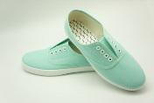
27 | children | canvas
2 | children | canvas
38 | children | canvas
12 | children | canvas
4 | children | canvas
2 | children | canvas
1 | children | canvas
8 | children | canvas
8 | children | canvas
8 | children | canvas
20 | children | canvas
10 | children | canvas
3 | children | canvas
6 | children | canvas
